St Francis de Sales, Lynbrook Dependant and Temporary Full-fee Paying Overseas Student (FFPOS) Application Form
Policy subtitle
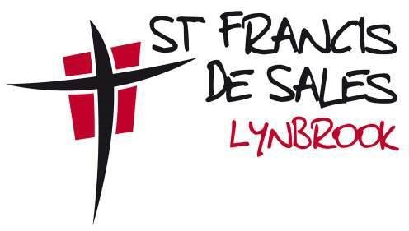

This application form is informed by the St Francis de Sales, Lynbrook Enrolment Policy and St Francis de Sales, Lynbrook Enrolment Processes. Please refer to these documents for further information. This application should be completed by the Principal or delegate, in consultation with parents/guardians/carers, and submitted to MACS for approval by the Executive Director (or delegate).
STUDENT DETAILS
Family name: | Given name:
Date of birth: | Gender:
Nationality on passport: | Country of birth:
Passport number: | Expiry date:
CONTACT DETAILS
Parent 1/guardian 1/carer 1 family name:
Parent 1/guardian 1/carer 1 name:
Parent 2/guardian 2/carer 2 family name:
Parent 2/guardian 2/carer 2 name:
Family contact number:
Family email address:
FAMILY AUSTRALIAN RESIDENTIAL ADDRESS
Street address:
City: | State:
Country: | Postcode:

PARENT’S/GUARDIAN’S/CARER’S COURSE ENROLMENT DETAILS
Please provide copy of letter of offer and certificate of enrolment.
Family name: | Given name:
Nationality: | Passport number:
Visa sub-class:  If bridging visa, please provide previous visa sub-class | Tertiary institute name:
Passport expiry date: | Visa expiry date:  If bridging visa, please write N/A
Course start date: | Course end date:

SIBLING DETAILS
Does the student have a brother or sister currently enrolled at a Victorian school? Yes No
If yes, which school do they attend?
Sibling name 1:
Sibling name 2:
Sibling name 3:
SPECIAL CIRCUMSTANCES
To ensure that your child is provided with the most appropriate support according to their needs, please provide details for all information requested.
Has the student been diagnosed with a medical or health condition?
If so, please provide details:

Does the student have any special learning needs?
If so, please provide details:

EDUCATION HISTORY
In what country has the student been studying? What year levels have been completed?
Current year level: | How many years of English language has the student studied?

STUDY PLAN
Proposed year level:
Proposed commencement date: | Proposed end date:

Application Fee
Application fee amount: 2023 | $302

Please refer to relevant international student fee rate schedule for updated fee on CEVN

Parent Consent
☐ By submitting this form, you consent to the information contained within the form being shared with relevant MACS employees for the purpose of considering your child’s application.
☐ I/We have paid the application fee to the school as part of the application process.
Parent 1/guardian 1/carer 1  signature: |  | Date:
Parent 2/guardian 2/carer 2 signature: |  | Date:

Checklist
The application process will not commence until the Dependant and Temporary Full-Fee Paying Overseas Students (FFPOS) Application Form is complete and all necessary supporting documentation is provided to the school. This will enable the school to seek approval from MACS.
The original documentation must be provided in the following format:
DOCUMENT
Birth certificate or passport page | document translated to English from original language  certified as a true copy of the original
School reports including a grading key for the most recent two years | document translated to English from original language  certified as a true copy of the original
A copy of the parent/guardian/carer’s visa | copy of the original document
Proof of medical conditions  and additional learning needs  (if applicable) | copy of original document/s  document translated to English from original language  (if required)

Approval authority | Director, Learning and Regional Services
Approval date | 16 October 2023
Next review | May 2025

